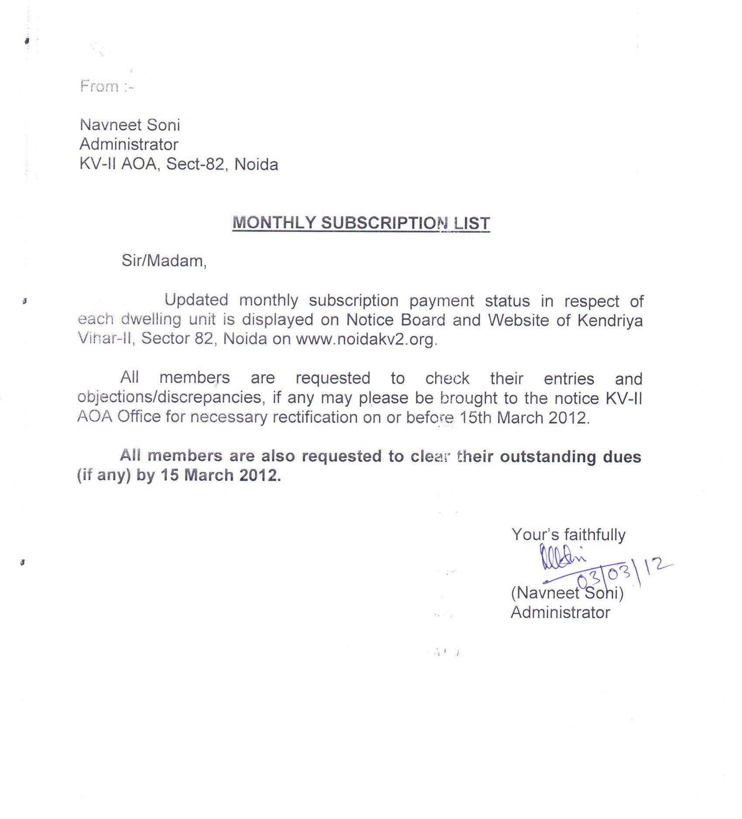
Sl. No. | Payment status in respect of | Please click following link + Ctrl  (after reading above notice)
1. | A Type | status in r/o A type apartments
2. | B Type | status in r/o B type apartments
3. | C Type | status in r/o C type apartments
4. | C1 Type | status in r/o C1 type apartments

